Vehicles control interface
Now you can control vehicles movement and target designation from F10 view. New features include:
- Changing formations in any moment
- Changing group speed and stopping
- Changing path for groups
- User-friendly dialog for setting targets
For doing all this things, you should open F10 view, and click on any vehicle in a cars group. You will see the vehicle control dialog, like on the screenshot below. In this dialog you can set formation and speed for cars column. These parameters would be changed immediately, just after you change it in the dialog. If the group has a path, it will be marked by red line with flag at the end.
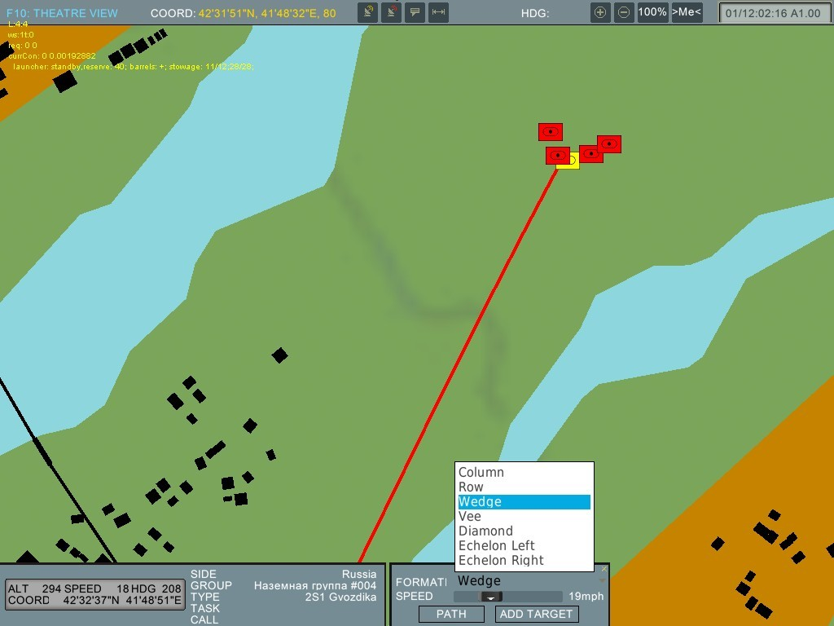
Next possibility is changing of the column path. Now you can set group path very easy by using “set path” dialog, but you should be cautious with this feature especially on difficult landscape. Although cars now try to avoid landscape obstacles, they can go on too steep slope or water and stop. The most difficult places are bridges and tunnels. “SET PATH” dialog activated by pressing the “PATH” bottom in “VEHICLE CONTROL” dialog. After that, you can click on any point of the map, witch you want to make the destination point. There will be red flag. You confirm you path (path will be calculated) by clicking “SET” button. You can also cancel existing path (in this case all cars will be stopped). “SET PATH” dialog has only one option. It’s “ROADS PRIORITY”. If “ROADS PRIORITY” is off, cars will be choosing straighter path. If there is no path or system can’t find it, group will go by straight line.
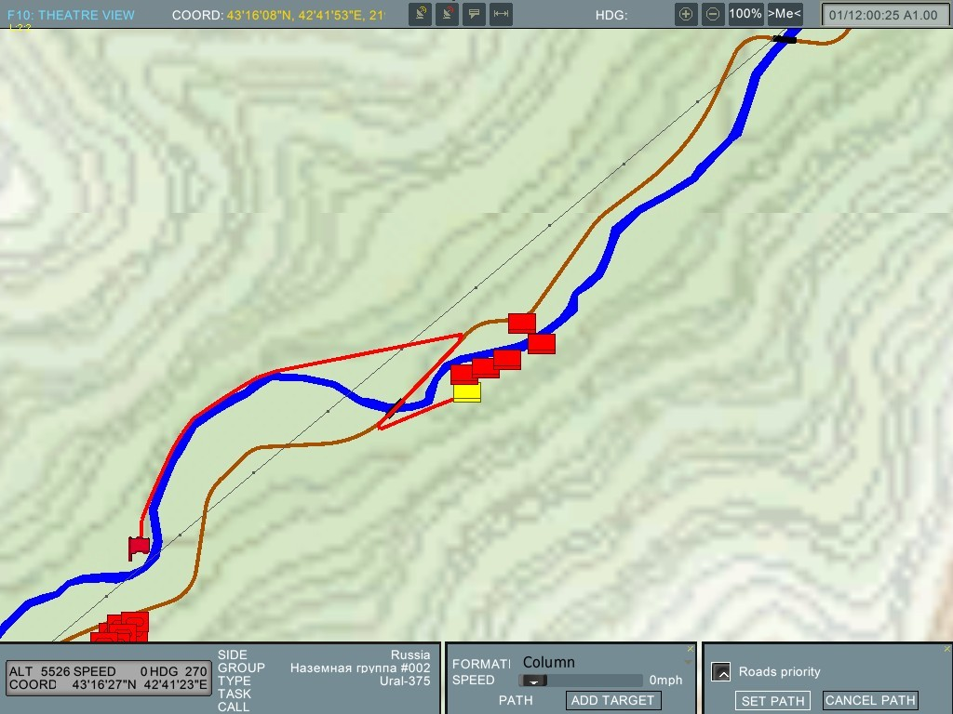
Setting target dialog also was modified. You can add targets for MLRS and howitzers by pressing “ADD TARGET” button and then choosing point on map, as you do this in set path dialog. Or you can fill in coordinates fields. When you set target on map, it is inactive. You can activate it by pressing “FIRE” button. Also you can change coordinates of existing target and use drag and drop to move it. This feature is under construction now, so you wouldn’t see, if some cars can’t fire on target. This dialog is active for all columns, but working only for MLRS and SPH.
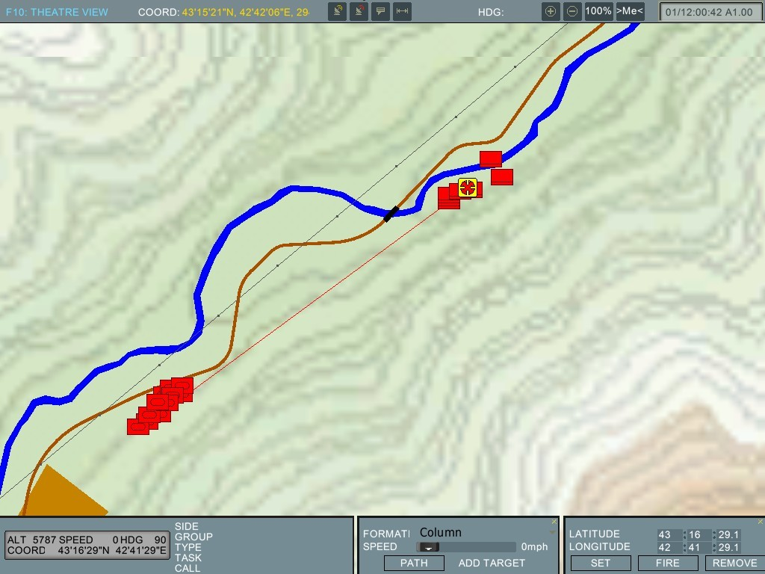

New AI Task System
DCS: A-10C has new task system for AI-controlled groups of unit. It provides to create flexible and detaily configurable AI group behaviour during a mission. Necessary improvements done both in AI engine and Mission Editor.
Architecture
There are main terms: controller, task, background task, action and behavior option.
Controller is a object that controls units or group of units.
Controller performs a tasks. Task is a process, so performing of task by controller requires a time. Flying route, following leader, engaging targets and performing a mission are samples of tasks.
There are two types of tasks: main tasks and background (en-route) tasks.
Main task is a solid and uninterpretable task. When performing this type of task controller each time is performing an actions those associated with this task. One and only one main task can be performing by controller same time. Task performing can be finished by itself or finished by user.
Performing mission, flying route, orbiting, engaging designed target or bombing designed point are samples of main task.
Background (en-route) task is a task that can be performing with main tasks simultaneously and can interrupts main task many times to perform associated with this background task actions. Several background tasks can be running same time one main task running. Background task can be finished by user only.
If you want order flight of battleplanes hunting enemy vehicles along the route you can assign “Flying Route” main task and “Engaging vehicles” background task to group controller. When new target detected group will interrupt flying route and start engagement. After engagement group will resume it's route.
Because several background tasks can be running at same time there may be a situation when several tasks at same time requires group to perform actions associated with these tasks. For example A-10 flight detected many targets while performing two background tasks. One task requires enemy armour engaging in one zone and enemy truck convoy attacking in second zone. Both target detected, but we want this flight to destroy truck convoy first. To solve this problem all background tasks has priorities.
Combo task is a task that combines several tasks (main or background), actions and behavior options those running one-by-one or switching by any other rule. Mission is a sample of combo task. When performing mission group following route and performing tasks and actions associated with each waypoint.
Actions don't require time for performing. Changing waypoint, changing radio frequency, jettison payload, restoring fuel and ammo are samples of actions.
Behavior options defines restrictions those has effect on controller behavior all time. When controller performing any tasks it stay under these restrictions. Options can be changed many times and at any time of mission. Behavior option can be represented by <variable> = <value> pair. “ROE” = “Return Fire”, “Radar using” = “Keep radars switched off”, “Aggressiveness”=“Low” are samples of behavior options.

